TALLER N°1
TEMAS: DIODOS
Recuerde que V_{u(Si)}=0.7V y V_{u(Ge)}=0.3V
- Hallar I_{R1}, I_{R2}, I_{R3} , I_{R4} , I_{D1,} I_{D2,} I_{D4}
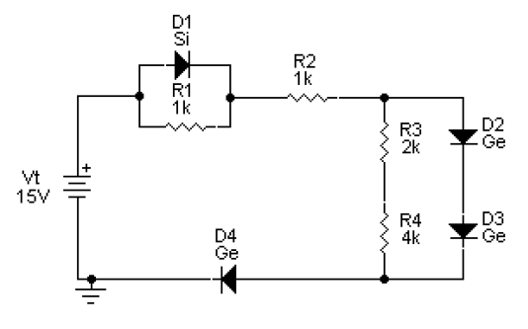
I_{R1} | 0.7 mA
I_{R2} | 13.4mA
I_{R3} | 0.1 mA
I_{R4} | 0.1 mA
I_{D1} | 12.7 mA
I_{D2} | 13.5mA
I_{D4} | 13.4mA

- Si I_{R3}=2mA y V_{R8}=3V.Hallar I_{R1}, I_{R2}, I_{R5} , I_{R6}, I_{R7}, I_{R8} , I_{D1,} I_{D2,} I_{D4} , I_{D5,} I_{D6,} V_{R2} , V_{R6} ,R₈, V_{T}
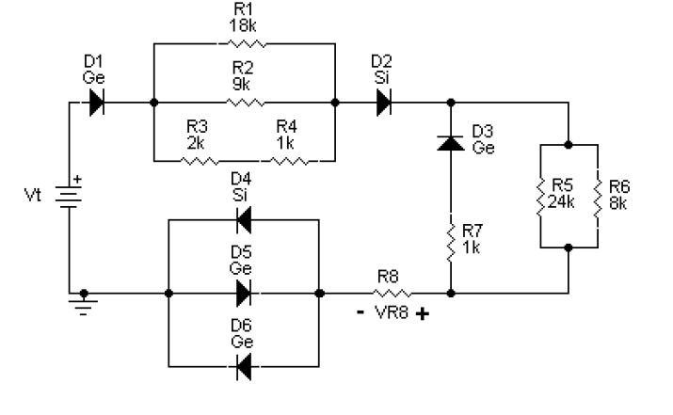

I_{R1} | I_{R2} | I_{R5} | I_{R6} | I_{R7} | I_{R8} | I_{D1} | I_{D2} | I_{D4} | I_{D5} | I_{D6} | V_{R2} | V_{R6} | R₈ | V _{T}
0.33mA | 0.67mA | 0.75mA | 2.25mA | 0 | 3mA | 3mA | 3mA | 3mA | 0 | 0 | 6V | 18V | 1K | 27.9V

- Hallar V_{R1}, V_{R2}, V_{R3} , V_{D1,} V_{D2,} V_{D3} , V_{D4}, V_{D5,} V_{D6,} I_{R1} , I_{R2} , I_{R3}, I_{D1,} I_{D2,} I_{D3} , I_{D4}, I_{D5} , I_{D6}

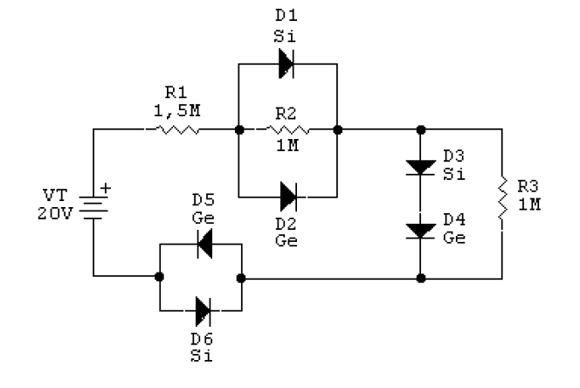
V_{R1} | V_{R2} | V_{R3} | V_{D1} | V_{D2} | V_{D3} | V_{D4} | V_{D5} | V_{D6}
18.4V | 0.3V | 1V | 0.3V | 0.3V | 0.7V | 0.3V | 0.3V | 0.3V
I_{R1} | I_{R2} | I_{R3} | I_{D1} | I_{D2} | I_{D3} | I_{D4} | I_{D5} | I_{D6}
12.3 µA | 0.3µA | 1µA | 0 | 12 µA | 11.3 µA | 11.3 µA | 12.3 µA | 0

